

College HR Management and Payroll System

Software Engineering Project
Group 2 - ninEngineers



BASIC INSTRUCTION MANUAL

This basic manual covers only the most basic operations.
For other features and more details, see the User
Manual

Group Members :

Sr. No. | ID | Name
1 | 201351023 | Murtuza Bohra
2 | 201351017 | Rahul Nalawade
3 | 201351024 | Shalinee SIngh
4 | 201351005 | Abhjit Panwar
5 | 201351006 | Yash Chobey
6 | 201352013 | Sameer Bhati
7 | 201352006 | Nitin Kumar Singh
8 | 201351021 | Manu Sharma
9 | 201351030 | Ajay Shewale

Introduction

Payroll system is the heart of any Human Resource system of an organisation. And there are lots of HR and Payroll management systems that serve many organisations under different circumstances. But, most of them are static and require modifications according to the organisational needs.
Our Institute is in its developing phase. And the existing HR and Payroll System is managed manually by the administration. Besides, current course on Software Engineering deliberately expects us to do a project that will help our institute somehow.
We have develop a software solution to address the efforts and time-consuming manual operations of existing Payroll management by incorporating the software engineering practices.

Setting Up a Local Web Server

Our website execute on a web server running PHP. So before you start using website you need following program installed on your computer.
- The Apache web server
- The PHP engine
- The MySQL database server
- phpMyAdmin



You can either install them individually or choose a pre-configured package for you operating system like Linux and Windows. Popular pre-configured package are LAMP and WampServer.
LAMP is for Ubuntu and WapmServer is for windows operating system. Below are installation process for both.

How to install Apache, MySQL, PHP (LAMP) on Ubuntu


LAMP
LAMP stack is a group of open source software used to get web servers up and running. The acronym stands for Linux, Apache, MySQL, and PHP. Since the virtual private server is already running Ubuntu, the linux part is taken care of. Here is how to install the rest.


Step 1 : Install Apache
Apache is a free open source software which runs over 50% of the world’s web servers.
To install apache, open terminal and type in these commands:
sudo apt-get update
sudo apt-get install apache2
That’s it. To check if Apache is installed, direct your browser to your server’s IP address (eg. http://12.34.56.789). The page should display the words “It works!" like this.

Step 2 : Install MySQL

MySQL is a powerful database management system used for organizing and retrieving data
To install MySQL, open terminal and type in these commands:
sudo apt-get install mysql-server libapache2-mod-auth-mysql php5-mysql
During the installation, MySQL will ask you to set a root password. If you miss the chance to set the password while the program is installing, it is very easy to set the password later from within the MySQL shell.
Once you have installed MySQL, we should activate it with this command:
sudo mysql_install_db


Step 3 : Install PHP
PHP is an open source web scripting language that is widely use to build dynamic webpages.
To install PHP, open terminal and type in this command.
sudo apt-get install php5 libapache2-mod-php5 php5-mcrypt

After you answer yes to the prompt twice, PHP will install itself.

Step 4 : Restart Server
Your server should restart Apache automatically after the installation of both MySQL and PHP. If it doesn't, execute this command.
sudo /etc/init.d/apache2 restart

Step 5 : Check Apache
Open a web browser and navigate to http://localhost/. You should see a message saying It works!

Step 6 : Check PHP
You can check your PHP by executing any PHP file from within /var/www/. Alternatively you can execute the following command, which will make PHP run the code without the need for creating a file
php -r 'echo "\n\nYour PHP installation is working fine.\n\n\n";'

YEAH, YOU HAVE INSTALL UBUNTU LAMP SERVER SUCCESSFULLY !!

For further queries visit :
https://www.digitalocean.com/community/tutorials/how-to-install-linux-apache-mysql-php-lamp-stack-on-ubuntu
How to install WampServer on windows

WAMP

WampServer is windows web development environment. It allows you to create web application with Apache, PHP, and MySQL database. Also PHPMyAdmin allows you to manage your database.
How to install?
Here is a link where you can download WampServer
http://www.wampserver.com/
- Click on download option and follow the instructions. Everything is automatic you dont need to do anything, It will install latest version of Apache, MySQL and PHP.
- Also for new release you can manually install Apache, MySQL and PHP.
- Click on the “localhost” link in the WampSever menu or open your internet browser and go to the URL : http://localhost

Step 1 : Installing WAMPSERVER
Download the latest version of WAMP Server
Double click the downloaded setup.exe file to install WAMP server as a local sever on your system. You’ll see the following window.
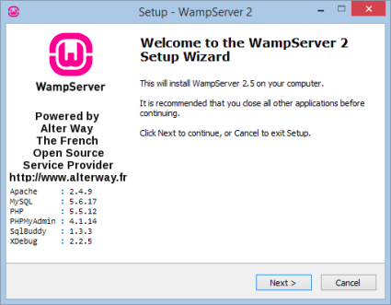

Click “next” to start installation process

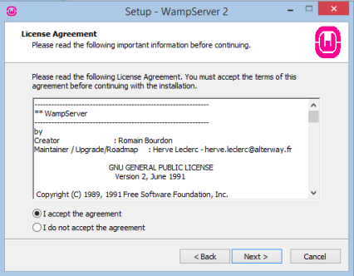

Select “I accept the agreement” and click “next”

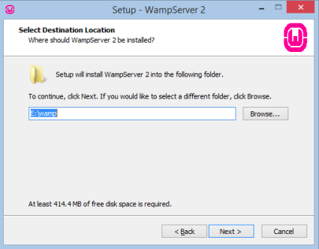

Click “Browse” and select where you want to install and click “next”

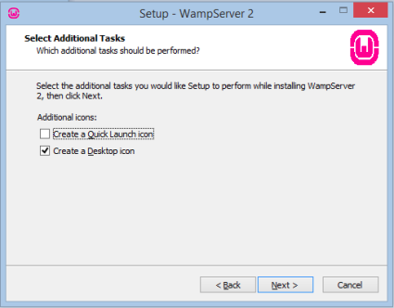

Select additional icons if you want and click “next”

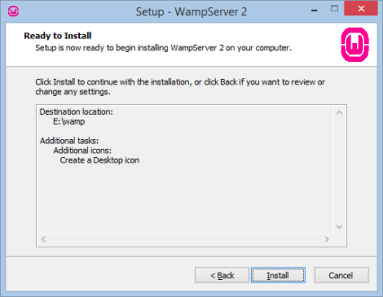

Click on “install” to preceed further

After installation following window will be displayed and click on “next”
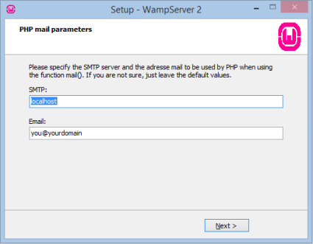

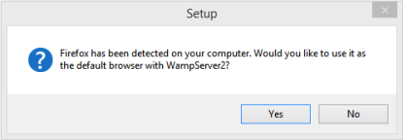

This message box will ask you whether you want to make Firefox as you default browser for WAMP Server. Click “Yes“.

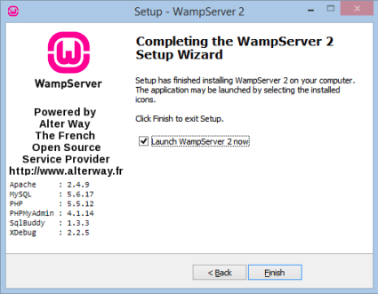

Click on “finish” , this will exit the setup and launch WampServer automatically

Step 2 : Installing PHP/MySQL Using WAMP
Make sure that you have installed WAMPSERVER successfully.
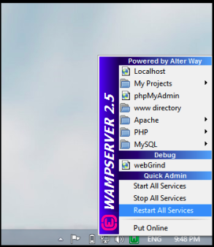
You will see new icon is added to your system tray which has green and reed color
Green color means you're going good and ready to use WAMPSERVER
Red color means there is some problem with your WAMP Server. To deal with this click on Wamp Server icon and choose command “Restart all services”.
For now, we suppose everything is okay and you are observing green color.

Now open any browser and type http//:localhost in the address bar and hit Enter! If you are seeing the page shown in the following picture then you’ve successfully installed Apache Server, PHP and MySQL just by instilling a single software.

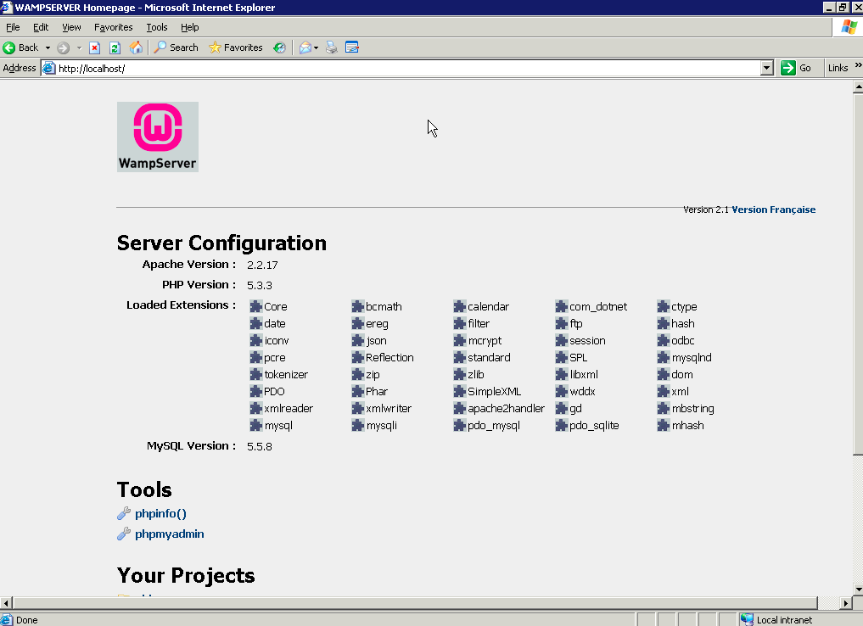

CONGRATULATIONS, YOU HAVE SUCCESSFULLY INSTALL WAMP AND PHP/MySQL ON WINDOWS !!

For further queries visit :
http://www.wampserver.com/en/

How to install phpMyAdmin on windows

phpMyAdmin

- Click WampServer icon in your System. This is located in the bottom-right corner of your desktop.
If the icon is green, WampServer is online. If the icon is a different color, you may need to try installing WampServer again.

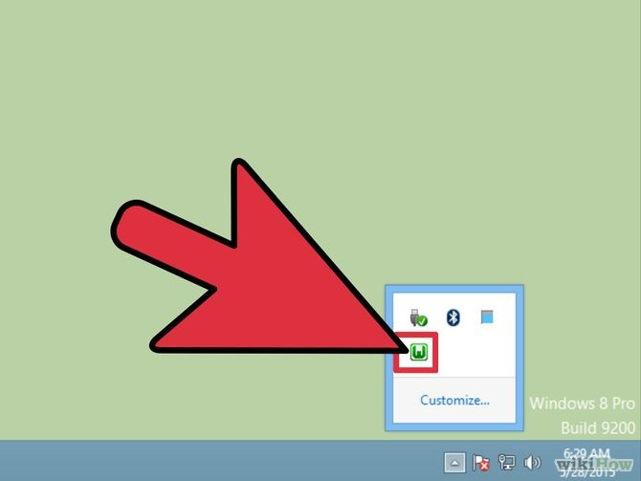

Select phpMyAdmin. This will open phpMyAdmin configuration page in your web browser.
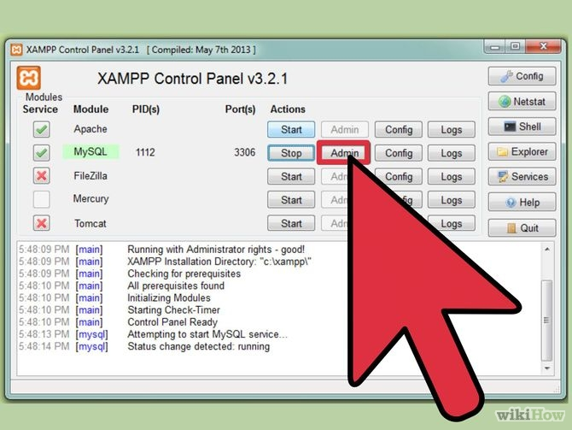

Start using phpmyadmin. You can now use phpMyAdmin to create new databases and manage users

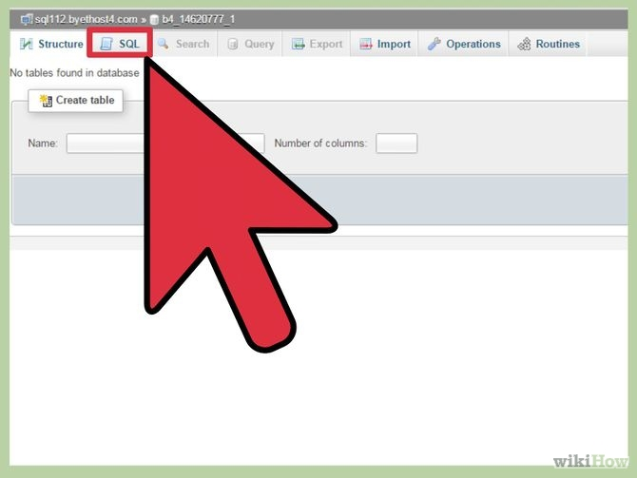

Creating MySQL database

A database created to hold all the website data and user information. We will set this database up using phpmyadmin.
To access phpMyAdmin you will need to know the IP address or domain name of your server.
Open your browser and enter the the IP address or domain name of your server followed by /phpmyadmin

Login Page

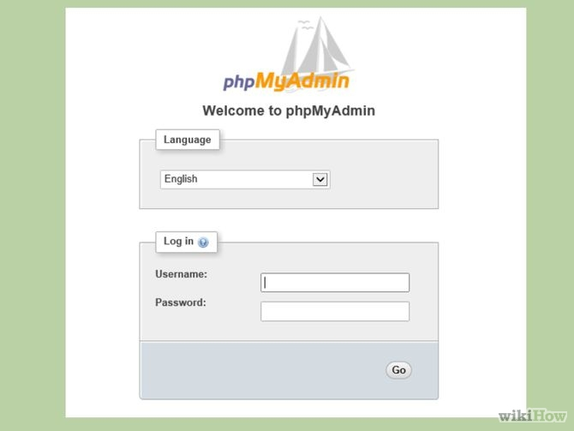

Login to phpMyAdmin : Enter root as a username and enter your MySql password in password field.
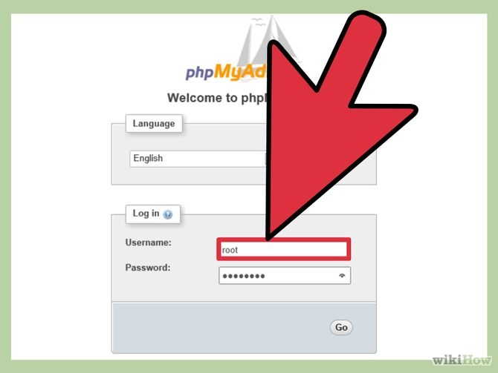

Create an empty database from the database tab

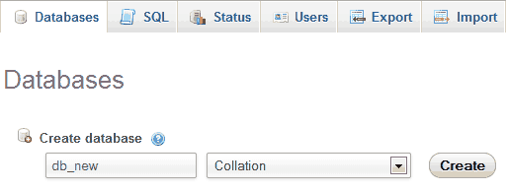
Write a database name in the “Create database” textfield, and click on Create
button. A database will be created.

Import database
- Click the Import tab.
- Click the Browse button.
- Locate the file to be imported.
- Click Open or OK, depending on your browser.
- Select the proper collation from the drop-down.
- Select the format of the import file.
- Click Go.

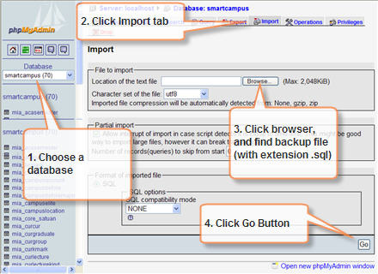

Running scripts
Before running PHP files, they should be placed inside the web folder of a web server and then make a request to desired PHP file by typing its URL in the web browser If you installed a web server in your computer, usually the root of its web folder can be accessed by typing http://localhost in the web browser. So, if you placed a file called hello.php inside its web folder, you can run that file by calling http://localhost/hello.php.

Windows users: WAMP

I will assume that you have launched the servers. (See instructions above.)
To be runnable, your scripts (and HTML, images and stylesheets) must be placed in the following folder: C:\wamp\www. (You can reach this folder more quickly by left-clicking on the WAMP icon in your System Tray and choosing www directory from the menu.)
Suppose you have placed a script called greetings1.php into the folder. Simply double-clicking it will not run the script.
Instead, you must open your browser and type in the following URL:
http://localhost/greetings1.php
Obviously, if you had placed greetings1.php in a subfolder of C:\wamp\www, then you would need to include that subfolder's name in the URL.

Linux users: LAMP

To run scripts they must be in the folder /var/www/ If you have a script called greetings1.php you will have to browse to http://localhost/greetings1.php to view it.

